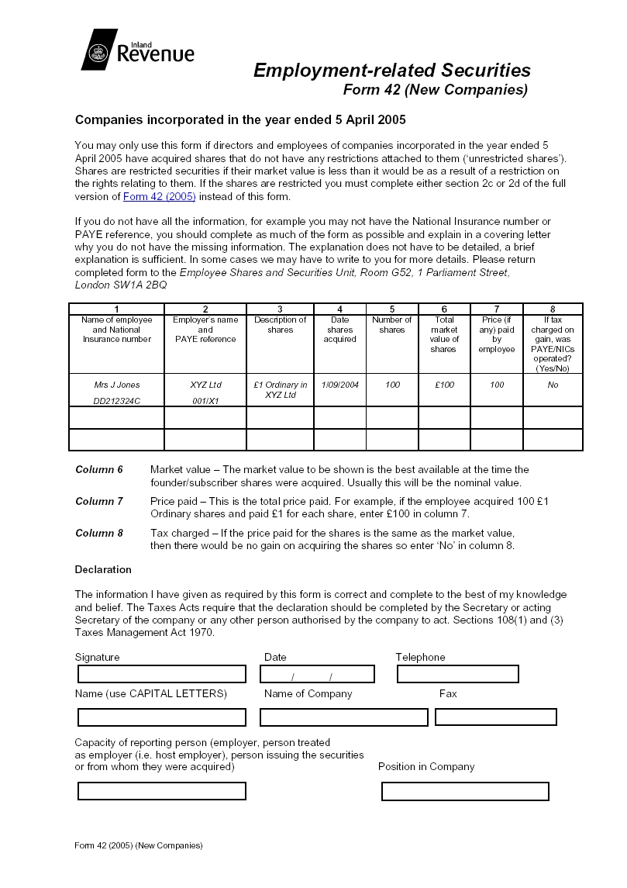
MR MARK J DURBIN  NA 52 76 63 A | CYKOR SYSTEMS LTD  NOT TRADING YET | £1 ORDINARY IN CYKOR SYSTEMS | 16/02/2005 | 50 | £50 | £50 | NO
MRS CLAIRE R DURBIN  NE 41 49 32 A | CYKOR SYSTEMS LTD  NOT TRADING YET | £1 ORDINARY IN CYKOR SYSTEMS | 16/02/2005 | 50 | £50 | £50 | NO

MARK J DURBIN
CYKOR SYSTEMS LIMITED
N/A
(01295) 270890
11 05 2005
EMPLOYER
DIRECTOR

